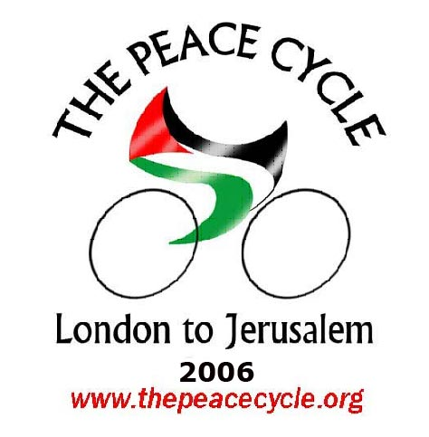
End the Cycle of Violence.
Support the Cycle for Peace

Cyclist Application Form:

Forename(s): Permanent Address:

Surname:

Gender:

Nationality:

Home Phone Number: (including International and STD codes)

Mobile Phone Number: (including International code)

E-mail:

Date Of Birth: (dd/mm/yy) Passport Number:

Country of Residence:

[The following two questions are optional, and are asked purely to assess how inclusive our recruitment methods are.]

(Optional) Ethnic origin: (Optional) Religious faith:

Next of Kin: Relationship: Daytime Telephone Number:

Evening Telephone Number:

Highest level of Academic/Vocational Achievement (i.e. GCSE, A-Level, NVQ, Bachelor/Masters degree, PHD):

Languages (and their proficiency [Basic/Intermediate/Fluent]):

Do you hold a Valid UK/EU Driving Licence?

Do you hold any certificates of achievement (i.e. Duke of Edinburgh, St Johns Ambulance, 1st Aid for Appointed persons)? (please specify)

Do you regularly participate in any sports activities? (please specify)

Are you a member of any Peace/Campaign/Religious/Political groups? (please specify)

Do you have basic cycle maintenance skills?

Do you have any disabilities / Special needs?

Dietary Requirements:

Blood Group:

What are your reasons for applying to take part in The Peace Cycle? (Max. 100 words)

What do you expect to achieve from taking part? (Max. 100 words)

What do you feel you will contribute to The Peace Cycle? (Max. 50 words)

What do you plan to do after the ride? (Max. 100 words)

I wish to take part in The Peace Cycle from LONDON to JERUSALEM.
OR
I wish to take part in The Peace Cycle from to .

I wish to be sent information on joining the Olive Harvest.

I agree that the information I have provided is accurate, to the best of my knowledge and by giving false information I am liable to have my application rejected. I enclose a non-refundable deposit of £250.

Signed: Date: (dd/mm/yy)

